**ÖDEV-2**

**1)**

**>> pay=[2 16 44 56 32]**

**pay =**

**2 16 44 56 32**

**>> payda=[3 3 -15 18 -12]**

**payda =**

**3 3 -15 18 -12**

**>> G=tf(pay,payda)**

**G =**

**2 s^4 + 16 s^3 + 44 s^2 + 56 s + 32**

**-----------------------------------**

**3 s^4 + 3 s^3 - 15 s^2 + 18 s - 12**

**Continuous-time transfer function.**

**>> [z,p,k]=tf2zp(pay,payda)**

**z =**

**-4.0000**

**-2.0000**

**-1.0000 + 1.0000i**

**-1.0000 - 1.0000i**

**p =**

**-3.2361**

**1.2361**

**0.5000 + 0.8660i**

**0.5000 - 0.8660i**

**k =**

**0.6667**

**>> zp2sos(pay,payda)**

**ans =**

**1 -56 0 1 -18 0**

**1 -76 1408 1 27 180**

**1 -18 32 1 -6 9**

**>> zplane(pay,payda)**

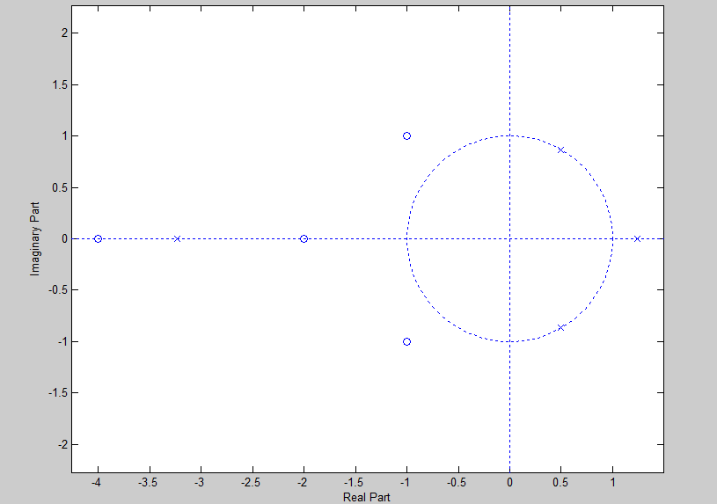

**2)**

**>> pay=[6 14 26 36 2 14 44 56 32]**

**pay =**

**6 14 26 36 2 14 44 56 32**

**>> payda=[7 1 3 12 33 3 3 -15 18 -12]**

**payda =**

**7 1 3 12 33 3 3 -15 18 -12**

**>> G=tf(pay,payda)**

**G =**

**6 s^8 + 14 s^7 + 26 s^6 + 36 s^5 + 2 s^4 + 14 s^3 + 44 s^2 + 56 s + 32**

**--------------------------------------------------------------------------**

**7 s^9 + s^8 + 3 s^7 + 12 s^6 + 33 s^5 + 3 s^4 + 3 s^3 - 15 s^2 + 18 s - 12**

**Continuous-time transfer function.**

**>> [z,p,k]=tf2zp(pay,payda)**

**z =**

**-0.2791 + 1.8688i**

**-0.2791 - 1.8688i**

**-1.7648**

**0.8770 + 0.7275i**

**0.8770 - 0.7275i**

**-0.8427**

**-0.4609 + 0.7492i**

**-0.4609 - 0.7492i**

**p =**

**0.9815 + 1.2775i**

**0.9815 - 1.2775i**

**-1.1375 + 0.7130i**

**-1.1375 - 0.7130i**

**-0.5837 + 0.9241i**

**-0.5837 - 0.9241i**

**0.6546**

**0.3410 + 0.5936i**

**0.3410 - 0.5936i**

**k =**

**0.8571**

**>> zp2sos(pay,payda)**

**ans =**

**0 1 -56 1 -51 594**

**1 -80 1584 1 3 -180**

**1 -58 832 1 5 -84**

**1 -28 196 1 -6 9**

**1 -8 12 1 -4 3**

**>> zplane(pay,payda)**

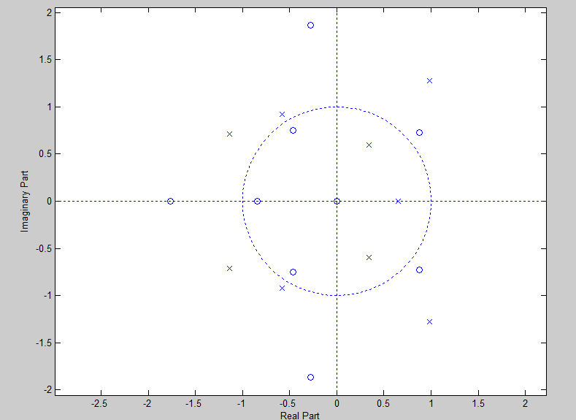

**3)**

**>> z=[4 3 3]**

**z =**

**4 3 3**

**>> p=[-0.45 0.67 0.81+0.72j]**

**p =**

**-0.4500 0.6700 0.8100 + 0.7200i**

**>> k=2.2**

**k =**

**2.2000**

**>> G=zpk(z,p,k)**

**G =**

**2.2 (s-4) (s-3)^2**

**----------------------------------**

**(s+0.45) (s-0.67) (s-(0.81+0.72i))**

**Continuous-time zero/pole/gain model.**

**>> impulseplot(G)**

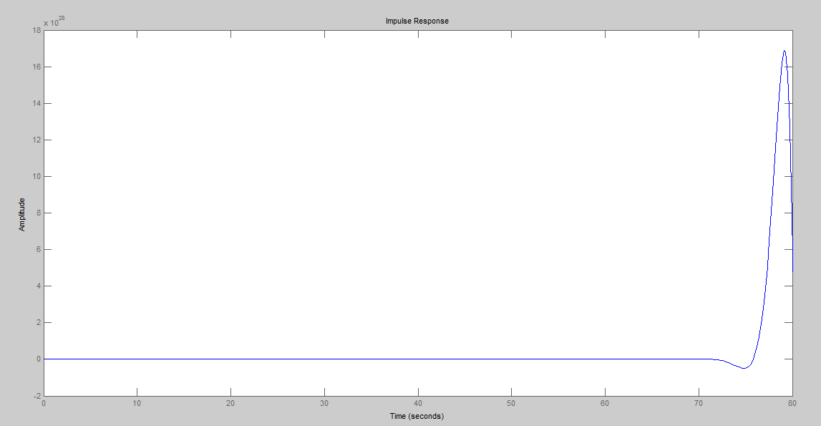

**>> step(G)**

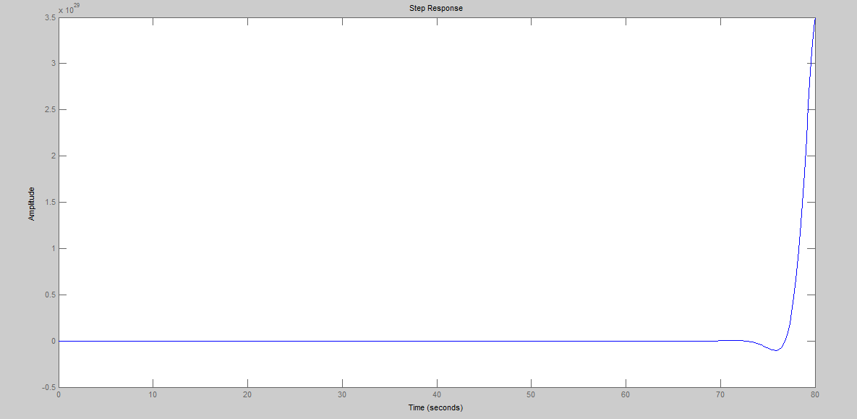

**4)**

**>> n=[18]**

**n =**

**18**

**>> d=[18 3 -4 -1]**

**d =**

**18 3 -4 -1**

**>> [r,p,k]=residue(n,d)**

**r =**

**1.4400**

**-1.4400**

**-1.2000**

**p =**

**0.5000**

**-0.3333**

**-0.3333**

**k =**

**[]**

**5)**

**pay=[0.008 -0.033 0.05 -0.033 0.080]**

**pay =**

**0.0080 -0.0330 0.0500 -0.0330 0.0800**

**>> payda=[1 2.37 2.7 1.6 0.41]**

**payda =**

**1.0000 2.3700 2.7000 1.6000 0.4100**

**>> x=tf(pay,payda)**

**x =**

**0.008 s^4 - 0.033 s^3 + 0.05 s^2 - 0.033 s + 0.08**

**-------------------------------------------------**

**s^4 + 2.37 s^3 + 2.7 s^2 + 1.6 s + 0.41**

**Continuous-time transfer function.**

**>> bode(x),grid**

